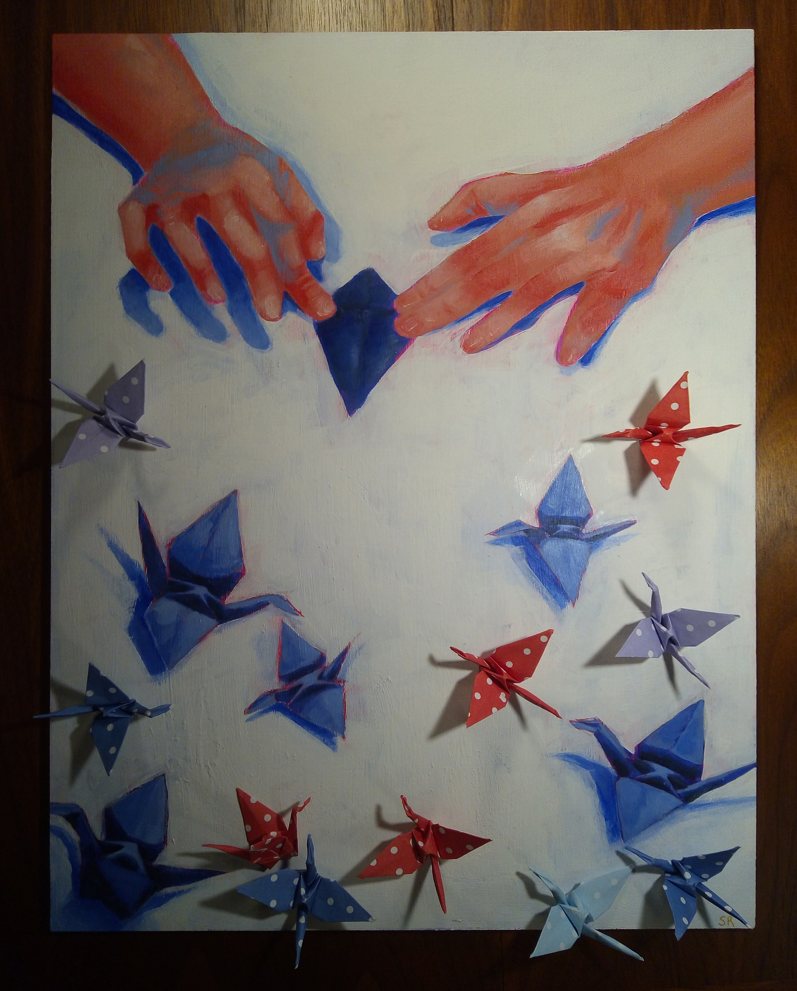

|  |
| --- |
| CLC Capstone Project Journal Sample |
|  |
| 2022    Sophie Rao |

# Questions

|  |
| --- |
| Is there any specific way to display art on a website portfolio?  Are there any design elements specific to the year (Ex. Trends in 2022)?  Are there companies that produce the products for you, given the art? Is that a viable option for artists new to selling there art?  What theme should **I** go for?  Try out a few products first; which ones?  How do I spread my portfolio and subsequent sites to buy art from me? |
| *“How can I represent my art in a succinct yet stylistically representative of me?”* |
|  |

Making a base website for my art

🡨 Title page

🡨 Navigation Bar

🡨 Art that repeats between sections of text

🡨 Repeating section of text

Difficult Code Sections… Found a solution for online, and edited to fit my code:

My CSS Code for the alternating backgrounds:

Source Code From:

<https://www.w3schools.com/howto/howto_css_parallax.asp>

To work on: Implementing layers

<https://medium.com/@dailyfire/pure-css-parallax-simple-tricks-da102d0ffdb9>

What I Want and Will Work To?

Add a gallery with dominant photos:

<https://www.pixpa.com/blog/artist-portfolio-websites>

<https://www.booooooom.com/2017/09/06/19-art-portfolio-examples-for-inspiration/>

<https://zyro.com/blog/artist-portfolio-website-examples/>

Add a section for social media!

I want a site that, like it’s name, is a portfolio. However, coding an interactive website for sales is too complicated and finnicky, so if I want to have a place to sell art, too, will have to link to another pre-existing shopping site (ex. Redbubble, Etsy).

Therefore, I will have the main portfolio site, which really showcases my art, and a linked Redbubble/Etsy shop where customers can actually purchase something.

Process/Plan:

* Code a portfolio website by myself
* Curate/make art to put on portfolio
* Create accounts on sites such as Redbubble and Etsy 🡪 Can sell art!
* Put art on here as well
  + Research and turn existing art into the correct formats for certain products (ex. Cutouts for stickers and keychains, etc.)
* Promote portfolio and accounts on social media 🡪 Hopefully gain traffic from one site to another

Research on Redbubble and Etsy:

Etsy:

* Great for selling your own products, produced by yourself!
* However, hard to get traffic and attention
* Harder, but not impossible to make money
* Will have to produce all products by myself
* Having a large social media presence really helps to send traffic to Etsy shop!
  + Unfortunately, I don’t have that

<https://www.redbubble.com/>

<https://www.adamenfroy.com/how-to-sell-on-etsy>

Redbubble:

* Creates the products for you! All you have to do is send in your own art
* However, takes a cut from whatever you make
  + There is the fact that they DO make the products, which is usually a huge cost and time-consuming activity
    - Default set to Redbubble takes 80% of profits… can change yourself a little

<https://www.michaelessek.com/sell-on-redbubble/#:~:text=By%20default%2C%20Redbubble%20sets%20the%20artist%20margin%20to%2020%25>.

<https://help.redbubble.com/hc/en-us/articles/202270799-How-much-do-I-earn-from-my-sales->

<https://www.quora.com/What-percentage-does-Redbubble-take>

<https://www.redbubble.com/>

What sells better?

<https://printbest.com/blog/11-products-that-artists-are-making-money-with-in-2021/>

<https://www.etsy.com/listing/981130694/mp100-slice-of-life-post-cards?ref=shop_home_recs_2&crt=1>

Postcards, prints, and maybe keychains, are the easiest to produce

Art won’t have to be formatted as much this way

Printing can also be done by myself in small numbers!

<https://photolab.londondrugs.com/>

Example prints:

